

Year 9 Science
CAT 3 - Electricity Test

Name:_________________________________ Form: ___________

Part A | Multiple choice |  | /16
Part B | Short answer questions |  | /29
Total |  |  | /44

Emerging
Working towards the standard
At the standard
Above the standard
Well above the standard

Part A – Multiple choice
Circle one correct answer only. Each question is worth 1 mark. (Total- 16marks)
1. What is the flow of electric charge called?
A. Voltage
B. Resistance
C. Current
D. Power

2. Which material allows electricity to pass through easily?
A. Plastic
B. Rubber
C. Copper
D. Glass

3. Which component opens and closes a circuit?
A. Resistor
B. Ammeter
C. Switch
D. Battery

4. Which of the following shows the symbol for a cell in a circuit diagram?
A. 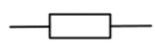
B. 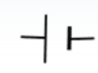
C. 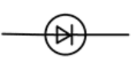
D. 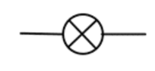
5. A resistor:
A. Measures voltage
B. Provides energy
C. Opposes current flow
D. Stores charge

6. Which of the following statements is true for a series circuit?
A. Voltage is the same everywhere
B. Current splits across each component
C. Resistance decreases when more resistors are added
D. Current is the same through all components

7. Which of the following statements is true for a parallel circuit?
A. The current is the same in each branch
B. The voltage splits across each branch
C. The voltage is the same across each branch
D. The total resistance is always high

8. If a wire becomes thinner, its resistance:
A. Stays the same
B. Decreases
C. Increases
D. Doubles

9. A thermistor’s resistance decreases when:
A. The light intensity increases
B. The temperature increases
C. Voltage increases
D. Temperature decreases

10. A light-dependent resistor (LDR) will have low resistance when:
A. It is dark
B. Temperature is high
C. The circuit is open
D. It is bright

11. LEDs must be connected the correct way because:
A. They only light up when placed vertically
B. They only allow current in one direction
C. They measure light levels
D. They increase voltage

12. What happens to resistance when more resistors are added in series?
A. Increases
B. Decreases
C. Stays the same
D. Doubles then halves

13.Which of the following components is used to measure electric current in a circuit?
A. Voltmeter
B. Ammeter
C. Thermistor
D. Resistor

14. What happens to the brightness of bulbs in a series circuit if more identical bulbs are added?
A. They get brighter
B. They stay the same
C. They get dimmer
D. They explode
15. A student builds a circuit with two identical bulbs in parallel. If one bulb burns out, what happens to the other?
A. It also goes out
B. It gets brighter
C. It stays on
D. It flickers then stops

16. The circuit shown in the diagram below contains a 12 V battery and two resistors: 4 Ω and 2 Ω in series. What is the total resistance of the circuit?

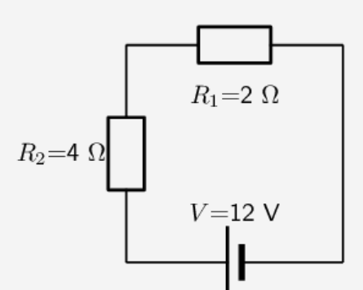
A. 2 Ω
B. 12 Ω
C. 6 Ω
D. 24 Ω

Part B – Short answer questions (Total 30 marks)
Question 1
Write the correct units including unit symbols for the following: (2 marks)
a) Current: __________
b) Resistance: __________

Question 2
Why is it dangerous to use electrical devices near water? (1 mark)
________________________________________________________________________
________________________________________________________________________

Question 3
Draw a labelled circuit diagram that includes:
- A battery
- A switch
- Two bulbs in parallel
- A voltmeter across one bulb
- An ammeter to measure total current
(5 marks)

Question 4
Describe two advantages of connecting bulbs in parallel instead of in series. (2 marks)

________________________________________________________________________
________________________________________________________________________
________________________________________________________________________
________________________________________________________________________
Question 5
Use Ohm’s Law (V = I x R) to solve the following:
(show working out for each calculation) (2 marks each, 6 marks total)
a) A circuit has a resistance of 8 Ω and a current of 3 A. Calculate the voltage.
________________________________________________________________________
________________________________________________________________________
b) A lamp is powered by 9 V and the current through it is 0.5 A. Find its resistance.
________________________________________________________________________
________________________________________________________________________

c) A motor has a resistance of 15 Ω and needs a voltage of 60 V. Find the current flowing through it.
________________________________________________________________________
________________________________________________________________________

Question 6
A student connects three identical 6 Ω resistors:
(show working out for each calculation)
Calculate total resistance when he connects these resistors in series. (1 mark)
________________________________________________________________________
________________________________________________________________________

Question 7
Explain what happens to the current if the resistance is doubled and the voltage stays the same. (2 marks)
________________________________________________________________________
________________________________________________________________________
_______________________________________________________________________
________________________________________________________________________

Question 8
The diagram below shows a simple series circuit that has a 12 V battery and two identical bulbs.

a) What is the voltage across each bulb? (1 mark)
________________________________________________________________________
________________________________________________________________________
b) If each bulb has a resistance of 6 Ω, what is the current in the circuit? Show your working out. (2 marks)
________________________________________________________________________
________________________________________________________________________

Question 9
A student wires an LED backward, and it doesn't light up. Explain why the LED must be connected in the correct direction. (2 marks)
________________________________________________________________________
________________________________________________________________________

Question 10
A student notices the current increases when the voltage increases. Explain this using Ohm’s Law. (2 marks)
________________________________________________________________________
________________________________________________________________________
________________________________________________________________________
________________________________________________________________________

Question 11
Explain how the resistance of an LDR changes with increasing light intensity. (2 marks)
________________________________________________________________________
________________________________________________________________________
________________________________________________________________________
________________________________________________________________________

